Kyushu University Q-Energy Innovator Fellowship
Application Guidelines (for October 2021) [Revised Version]

1. Purpose
"Q-Energy Innovator Fellowship" (hereinafter Q-Energy Fellowship) provides a research grant to excellent doctoral students in Kyushu University who are hopefuls of advancing science, technology and future innovation in Japan. This grant is created in line with the "University Fellowship Project for the Creation of Science and Technology Innovation" established by the Ministry of Science and Education, Culture, Sports, Science and Technology. It offers combined support of funds; research expenses, and research support allowance which aims to free students from financial concerns and enables them to concentrate on their research.

Q-Energy Fellowship aims to strategically cultivate "GX doctorate students" who have the vision of realizing a decarbonized society and will lead Green Transformation (GX). To achieve this aim, this Fellowship has programs to nurture students’ strong research ability and perspective views on their research.
The program offers opportunities for students to study on Kyushu University’s strong areas; Frontier Energies such as hydrogen, geothermal energy, wind power, and CO2 capture; and Decarbonized Systems in society such as mobility.
It provides environments to broaden students’ horizon with online courses of one’s choice both in the humanities and science field, collaboration with industry and organizations inside and outside of Japan, and presentation opportunities.

Program Outline (also refer to Fig. 1)
[Cultivate strong research abilities and support career paths]
● A variety of online lectures which enable students to acquire broad views and deep understandings of decarbonized energy
● Opportunities to participate in government’s research projects and joint researches with private sectors and universities overseas.
● Discussions in joint seminars which transcend the boundaries of laboratories, specialties and faculties

[Help secure career path]
● Opportunities of internship at partner companies, universities overseas, and local governments
● Presentation to partner companies which have on-campus labs.
Details of the research and career development programs in this fellowship are shown in the
attached table.

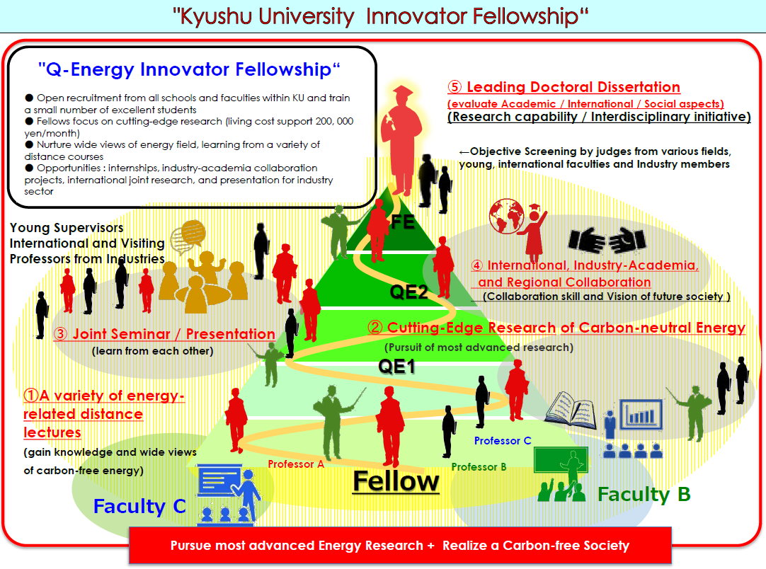
Figure1: Overview of Q-Energy Fellowship

2. Applicant Eligibility
Eligible Applicants should meet the following requirements (1) to (4).

- Graduate school students of Kyushu University as of October 1, 2021 who fall under or are expected to fall under;
i First year in doctoral course (less than 12 months) with a standard study period of three years
ii Third year in doctoral course ( between 24 and 36 months) with a standard study period of five years
iii Second year in doctoral course (between 12 and 24 months) with a standard study period of four years
* A leave of absence is not counted if it is six (6) months or more
- Under age 30 as of April 1, 2021 (under 33 for medical school students who have taken clinical trainings). If you are above the specified age for such reasons as childbirth or childcare, please state that in the form.
(3) Aspire to engage in decarbonization energy area and willing to work in line with the purpose of human resource development stated in Green Transformation Doctoral Program.
(4) Those who do not fall under any of the followings:
i Recipient of the Japan Society for the Promotion of Science’s Research Fellowship for Young Scientists
ii International student receiving scholarships via the Monbukagakusho Scholarship
iii International student receiving scholarships from their home country
iv Working student An individual who holds a job (an individual who is currently engaged in work for which he or she earns salary, wages, remuneration, or other ordinary income.) , An individual who has already retired from work for which he or she earns salary, wages, remuneration, or other ordinary income ,A stay-at-home mother or stay-at-home father.
v Receive scholarships and funds from other organizations and are not allowed to receive
financial support from the other organizations.

3. Obligations
Fellows are requested to:
- concentrate on their study and researches according to a set research plan.
(2) participate in joint seminars (see Appendix 2), give presentation in conferences with industry and affiliated universities (see Appendix 3), participate in internships and joint research in industry-academia collaboration, international collaboration, and regional collaboration to upgrade research skills and collaboration skills; also endeavor to bring the research results to publication in international journals, and presentation in international conferences.
(3) make progress report of their research at least once a year and also participate in education programs related to fellowship.
(4) report the research fund usage if requested.
(5) comply with regulations which promote sound research activities.

4. Supervisor’s Participation
Supervisors are requested to act in line with the policy of this program and Kyushu University’s "Da Vinci Program" which calls for collaborations between students and research supervisors ― burden sharing (See the attached chart for details) and fulfill the following requirements;
- Actively participate in the "Joint Seminar" where students and research supervisors of Q-Energy Fellowship gather and hold regular discussions (see Appendix 2).
(2) Understand the importance of your student’s participation in industry-academia collaborative researches, international collaboration researches, and regional collaboration researches, and support your students.
(3) Strive to obtain external research funds and actively support your student with research funds required to promote the student’s research.
(* Fellows are allowed to serve as research assistants (SRA/RA) or teaching assistants (TA) during the fellowship.)

5. Announcement
Selected fellows will be announced and listed on the university's website.

6. Fellowship Grant
(1) Research Support grant: 2.4 million yen per year [200,000 yen per month]
(2) Research Expenses support (for research activities): up to 100,000 yen per year.
The fund which starts or stops in the middle of a month is calculated in accordance with the university rule.

7. Pay Period
The grant payment period is three years.
(However, the payment period may be shortened if the payment suspension/stoppage requirement is met.)

8. Number of Applicants to be Accepted
Q-Energy Fellowship: 6
(* This recruitment is for students who start in October 2021 and April 2021.)

9. Application & Selection Guideline
(1) Application Deadline: 13:00 on August 6, 2021
(2) Application Documents: Submit the following documents in data file through the administration office of your department.
However "Supervisor Recommendation Form"-c, should be sent by a supervisor with signature in PDF format to Research Support and Public Relations Group, I2CNER / Q-PIT Research Support Service Office.
(E-Mail: iq-kenkyu@jimu.kyushu-u.ac.jp)

The application form can be downloaded from the website.
(Q-PIT URL) http://q-pit.kyushu-u.ac.jp
a Q-Energy Fellowship Application Form [Word]
b Estimation of Research Expenses [Excel]
c Supervisor Recommendation Form [PDF]
d Eligibility Check Sheet [Excel]
e Published paper, master's dissertation, etc. [PDF]

(3) Selection Process (see Fig. 4 on the appendix)
1 Applicants’ documents are reviewed from the viewpoints of "Innovation / Originality of Research Ideas", "Concreteness / Feasibility of Research Plan", "Dissertation and Presentation at International / Domestic Academic Conferences"
2 Applicants who passed the document screening, are requested to make presentation of their previous research and future research plans. There will be a question session to examine the candidate’s "Basic Knowledge in Their Research Fields", "Significance of Realizing a Carbon-free Society" and "Presentation Skill (to see if presentation is delivered in a manner where researchers from other fields understand".

(4) Selection Schedule
Application Deadline August 6th
Document screening August
Interview September
Final decision September
* The above schedule is planned and subject to change.

10. Research Grant Timing
(1) Research Support Grant
Paid by bank transfer onto fellow’s bank account on 21st of each month (or before 21st if it falls on Saturday, Sunday, or a holiday).
(2) Research Expenses Support (from this fellowship)
Approved amounts will be allocated in the research budget to be managed by each research supervisor.

11. Suspension / Cancellation / Return of Grant
(1) A grant may be suspended or terminated in the following events:
・ If a fellow falls under item (4) in clause 2. Applicant Eligibility
・ If a fellow takes a leave of absence (this is not applicable if a fellow can fulfill their requirement), drop out of school, or expelled from school
・ If a fellow has received disciplinary action
・ If an Annual Fund Review reports that a fellow has not fulfilled their obligations.
・ If it is decided that a fellow has failed to engage well enough in their study or a fellow’s behavior has been improper
・ In the event of a fellow’s death
・ If a supervisor does not support necessary research expenses
(2)In case the suspended or canceled research grant has already been transferred onto a fellow’s account, the fellow must immediately return the grant.

12. Resumption of Research Grant
If the reason for suspension is cleared, the grant may be resumed if it is deemed appropriate.

13. Tax Related to Research Grant
(1) A fellow must file a tax report, since the research support allowance is treated as miscellaneous income and is subject to taxation. The taxable amount is the total amount of annual research grant (January 1st to December 31st) minus research expenses such as tuition fees. In order to file a tax report, it is necessary to record income and expenditure, and also save receipts.
(2) A fellow is also obliged to pay "resident tax" to the municipality office of your residence (for foreign students, the tax is calculated according to the treaty between Japan and the student's home country.).

14. National Health Insurance
(1) Loss of dependent status
If a fellow has been registered as a dependent in his/her family member's health insurance, sailor insurance, or mutual aid association, and starts to make a total income of 1.3 million yen or more per year by receiving this grant, the fellow should be excluded from the dependents in such family health insurance, and he/she must join the National Health Insurance.
* Since the amount of national health insurance premium varies depending on a municipality, please check at the National Health Insurance counter of the city (ward) or town office of your residence.
*Also please advise those who have given a fellow a financial support (most probably parent) to confirm with the administration office of their workplace regarding dependents’ allowances provided.
(2) Payment of National pension premiums
All residents in Japan are obliged to pay national pension premiums starting at age 20. Students will be exempted from premiums payment while they are in school if their previous year's income is below a certain level*.
If your income goes above exemption level due to the receipt of this grant, you will be obliged to pay the National Pension premium.
* a certain level is estimated:
1.18 million yen + number of dependents x 380, 000 yen + deduction of social insurance premiums
* For more details, please check at national pension counter of the city (ward) or town office of your residence.

15. Contact information
I²CNER / Q-PIT Office Support Office of Research Service / Public Relations Group
email: iq-kenkyu@jimu.kyushu-u.ac.jp TEL: 90-6644, 7196

(Appendix)
Program for upgrading research capability and career development
Research capability | Expected achievement / Evaluation, [toward career path] | How to evaluate
Concept & Idea / Proposal | Document Screening:  Evaluate research proposals from the perspectives of 1. Innovation and originality of the research concept 2. Detail and feasibility of the research plan, and 3 Research dissertations and presentations at international and domestic conferences.  Interview : Presentation of the research  and future plans  Question and answer session: Assess  the understanding of the basics of  related fields and social significance of realizing a carbon-free society and presentation skills to see if it was easy to understand even to researchers outside the specialty area.  [Confirm basic capability to lead to career path] | fellowship selection time | Evaluate Research Plan  Oral screening on the research proposal: from academic, international, and social aspects (evaluation by FE) and assess the student’s initial ability.
Comprehension on decarbonized energy and ability to see the specialty field in perspective | Fellows take a wide range of online lectures related to decarbonized energy and expected to learn to have full view picture of energy fields.  [Raise awareness and provide opportunities to think about career path] | first Year | QE1 (Comprehension)  Oral screening (It is recommended that students take lectures from the master's program before participating in this fellowship)
Ability to conduct cutting-edge research and learn from others | Able to make a proposal to connect their own research seeds (materials, devices, systems, social systems reform, etc.) to social needs (improvement of environment, economy, and sociality) through the experiences of presentations and discussions with students and faculty members from different fields, different grades, corporate researchers, and foreign faculty members at joint seminars and presentation meetings with industries.  [Open up the door to academia, industry, and overseas universities] | every year | Presentation in joint seminars & discussions, and research progress in one’s own laboratory Performance Evaluation
Collaboration / Concept of future society | Develop ability not only to deepen one's own research through hands-on experience but also to understand the challenges in realizing a decarbonized society, involve people concerned and envision the picture of future society by joining one of the following projects: 1 Industry-academia collaboration research ― one month (or longer) internships and joint research at companies and institutes) 2 international collaboration research ― half a year (or longer) study at a university overseas, or joint research ― with non-Japanese researchers 3 Regional collaboration ―activities inside community.  [Gain clear picture of future career through hands-on experiences] | second  year | Project participation; Industry-academia collaboration, international collaboration, and regional collaboration research (Choose one)
Research ability / interdisciplinary work | Evaluate whether a fellow has potential to become an innovative researcher and able to carry out cutting-edge research from the perspectives of the followings.  ● Interim evaluation of dissertation (first half of the final year)  evaluate whether the progress of research, pending issues and research plans are all clear.  ● Final evaluation of dissertation (second half of the final year)  (1) Academic (originality and specialty)  (2) International (internationally accepted or not)  (3) Sociality (feasibility of realizing a carbon-free society)  This course can be completed early. [Dissertations with one’s own career path in sight. In case of carrier at a university overseas in sight, dissertation must be in English and must be able to respond to questions in English] | third year  ・  final year | QE2 (Research Progress Evaluation) Oral Screening on the achievement in interim research  FE (Doctoral Dissertation Review)  Examine objectively in accordance with the screening policy of each school or faculty and secure world standard papers.

