Research Proposal_2(Doctoral Students)
2. Purpose of Research, etc.
[Purpose of Research]
In this column, please describe an overall description and specific purpose of the research proposal. Specifically, describe the following:
(1) The scientific background of the research proposal
(2) The scientific specificities of the research proposal
<The scientific background of the proposed research project>
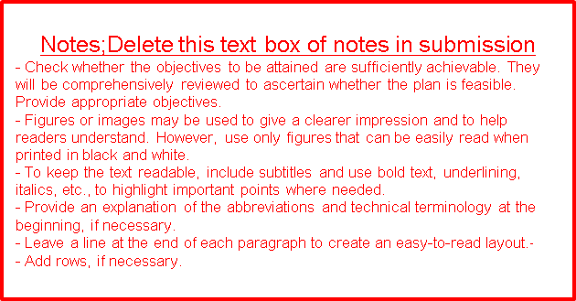

<Scientific specificities of the research proposal >

[Research Plan and Methods]
In this column, please describe research plan and methods to achieve the research proposal.

[Future Development of the Research]
In this column, please describe the detail plans that apply for the research fellowship for young scientists of the Japan Society for the Promotion of Science.
Application AY |  | Application Category
Title of the research
(Plan)
Outline of the research
Relation to this program

